The Write Stuff at Grace Cook Primary School
At Grace Cook Primary School, we are passionate about helping every child grow into a confident and capable writer. To achieve this, we use The Write Stuff approach, developed by leading education consultant Jane Considine. This exciting, creative, and structured programme brings consistency across the school while also making writing engaging and enjoyable for children.
Our Intent – Why We Teach Writing This Way
We want our children to:
- Develop a lifelong love of writing.
- Write fluently so they can share their thoughts, ideas, and emotions with others.
- Build a rich and varied vocabulary and know how to use it effectively.
- Write for a wide range of purposes, in both fiction and non-fiction.
- Speak clearly and confidently, using expression, while also listening attentively and contributing thoughtfully.
Implementation – The Write Stuff in Action
The Writing Rainbow
At the heart of The Write Stuff is the Writing Rainbow, which gives children the tools they need to become skilled writers. It is made up of three lenses:
- FANTASTICS – ideas for writing (e.g., feelings, senses, and observations)
- GRAMMARISTICS – the building blocks of writing (e.g., sentence structure, punctuation, and grammar)
- BOOMTASTICS – the techniques that make writing powerful (e.g., similes, metaphors, alliteration, onomatopoeia)
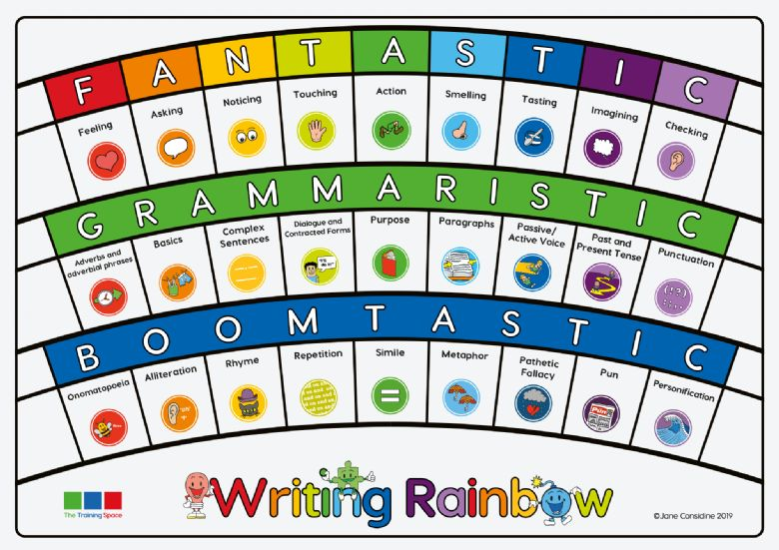

Sentence Stacking Lessons
Children take part in daily sentence stacking lessons, which break down writing into clear, manageable chunks. Each lesson focuses on one “plot point” from a class text and follows three stages:
- Initiate – This is where interest and engagement are built. It is a key time for children to build vocabulary, which is often supported by a creative stimulus, such as a picture or video to build ideas.
- Model – the teacher demonstrates how to craft a sentence, highlighting vocabulary, grammar, and writing techniques.
- Enable – children write their own sentence, using the model as guidance but adding their own creativity, building on the vocabulary they collected in the initiate stage.
These sentences are then “stacked” together, building up a piece of writing step by step. This provides lots of modelling, support, and opportunity for success.
Experience Days
Alongside sentence stacking, children enjoy experience days. These immerse them in rich, engaging activities linked to their writing – such as drama, role-play, or exploring artefacts – which provide meaningful inspiration for their work.
Independent Writing
After sentence stacking and experience days, children apply what they’ve learned in their independent writing. This is where they plan, draft, and edit a complete piece of writing for themselves.
Editing and Improving Writing
We place great importance on children learning how to edit and improve their work. We use three types of edits:
- E1: The Revise – small changes such as spellings, punctuation, or missing words.
- E2: The Rewrite – rewriting a sentence to improve sense, structure, or impact.
- E3: The Reimagine – adding more sentences to develop or extend an idea further.
Impact – What This Means for Our Children
Through The Write Stuff, children at Grace Cook Primary School:
- Learn to write for a wide variety of purposes (e.g., stories, diary entries, persuasive letters, reports, poetry).
- Gain a strong command of vocabulary to excite, inform, and engage their readers.
- Understand and use punctuation and grammar accurately and effectively.
- Become confident with different sentence types and text structures.
- Develop into articulate speakers and thoughtful listeners, able to contribute confidently to discussions.
Most importantly, our children will leave Grace Cook Primary School as enthusiastic writers who are ready to succeed in the next stage of their learning journey.

