Pupil premium strategy statement – Grace Cook Primary School and Nursery
This statement details our school’s use of pupil premium (and recovery premium) funding to help improve the attainment of our disadvantaged pupils for the 2025 – 26 academic year.
It outlines our pupil premium strategy, how we intend to spend the funding in this academic year and the outcomes for disadvantaged pupils last academic year.

School overview
Detail | Data
Number of pupils in school | 138
Proportion (%) of pupil premium eligible pupils | 26 Pupils - 35.8%
Academic years that our current pupil premium strategy plan covers | 2024-27
Date this statement was published | December 2025
Date on which it will be reviewed | December 2026
Statement authorised by | Helen Leeks  Chair of Governors
Pupil premium lead | Lisa Mayes - Headteacher
Governor / Trustee lead | Helen Leeks

Funding overview
Detail | Amount
Pupil premium funding allocation this academic year | £25,000
Pupil premium funding carried forward from previous years (enter £0 if not applicable) | £0
Total budget for this academic year | £25,000

Part A: Pupil premium strategy plan

Statement of intent
At Grace Cook Primary School, we are ambitious for all our pupils. We are committed to ensuring that the additional funding provided through Pupil Premium is used thoughtfully and effectively so that it has a strong, measurable impact on pupils’ academic progress, emotional well-being, and long-term life chances.
We recognise that disadvantaged pupils often face a variety of challenges — academic, social or emotional — which may inhibit their ability to achieve their full potential. Accordingly, our Pupil Premium strategy aligns with the DfE conditions of grant and the evidence-informed “menu of approaches” recommended by the EEF.
We commit to:
- Conducting a robust diagnosis of need: We will use internal data (attainment, progress, attendance, behaviour, well-being) alongside professional judgement and knowledge of individual pupils to identify barriers to learning, both academic and non-academic.
- Using research and evidence to inform decisions: As recommended by the EEF, we will draw on high-quality research (particularly the EEF’s “menu of approaches” and guidance documents) when selecting interventions or strategies.
- Prioritising high-quality teaching: We recognise that the single most powerful way to improve outcomes for disadvantaged pupils is to ensure effective teaching in every classroom. Therefore, we prioritise professional development, recruitment/retention of high-quality staff, and continuous improvement of pedagogy, curriculum, and assessment practice.
- Providing targeted academic support: Where gaps or needs are identified, we will implement structured interventions — such as one-to-one or small group tuition, or evidence-informed intervention programmes — carefully aligned with curriculum goals and monitored for impact.
- Addressing wider barriers to learning: Recognising that social, emotional, behavioural, and attendance issues can impede learning, we will allocate funding to support pastoral care, social and emotional learning, well-being, attendance, and other non-academic interventions.
- Ensuring equity for all disadvantaged pupils: Funding will benefit not only those eligible under Pupil Premium criteria (e.g. free school meals, Ever 6 FSM, looked-after children) but also other pupils with identified needs where appropriate — for example, pupils with social or emotional needs, or those with interrupted schooling or caring responsibilities.
- Focusing on impact, sustainability and continuous evaluation: We will implement interventions with care, monitor their effectiveness, and evaluate outcomes. Funding decisions will be revisited regularly and adapted in response to data and changing needs.
Our overall aim is to ensure that disadvantaged pupils at Grace Cook achieve high and rising standards, that gaps in attainment and opportunity are narrowed (and ideally closed), and that children’s well-being and personal development are supported so that they have the best possible chance to thrive — academically, socially and emotionally.

Challenges
This details the key challenges to achievement that we have identified among our disadvantaged pupils.
Challenge number | Detail of challenge
1 | In some cases, pupils eligible for Pupil Premium are not meeting age related expectations in reading, writing and mathematics
2 | Social and emotional issues for a small group of pupils eligible for Pupil Premium is having an impact on their readiness to engage with learning
3 | In some cases, support at home is inconsistent (home learning completion, volume of reading at home)
4 | In some cases, access to sporting and cultural experiences is limited

Intended outcomes
This explains the outcomes we are aiming for by the end of our current strategy plan, and how we will measure whether they have been achieved.
Intended outcome | Success criteria
Increased proportion of pupils eligible for Pupil Premium achieving age related expectations. | Pupils eligible for Pupil Premium achieve age related expectations in reading, writing and mathematics.
Social and emotional issues addressed for pupils eligible for Pupil Premium. | Fewer behaviour incidents recorded for these pupils on the school system.
Improved support for learning beyond the classroom | Pupils eligible for Pupil Premium are supported with home learning.
Increased opportunities for pupils eligible for Pupil Premium. | Pupils eligible for Pupil Premium experience planned enrichment activities.

Activity in this academic year
This details how we intend to spend our pupil premium (and recovery premium) funding this academic year to address the challenges listed above.

Teaching (for example, CPD, recruitment and retention)

Budgeted cost: £3000
Activity | Evidence that supports this approach | Challenge number(s) addressed
Pupil assessment and feedback: Assessment is used to identify areas where pupils have forgotten or misunderstood key concepts, to ensure that new material being covered builds on secure foundations. Standardised assessments in reading, writing and mathematics are used to identify pupils who would benefit from additional catch-up support. | When used effectively standardised tests can provide reliable insights into the specific strengths and weaknesses of each pupil to help ensure they receive the correct additional support through interventions or teacher instruction:  Feedback | EEF (educationendowmentfoundation.org.uk) | 1
TA access to training courses – PlayPod Training, School based CPD programmes & ongoing SDP priorities | Deployment of Teaching Assistants | EEF  https://educationendowmentfoundation.org.uk/projects-and-evaluation/projects/maximising-the-impact-of-teaching-assistants?utm_source=/projects-and-evaluation/projects/ | 1 and 2
Release for subject leaders to analyse the impact of the curriculum design on various pupil groups and to plan next steps. | Subject leaders are a key mechanism for identifying which pupil groups (e.g. disadvantaged, SEND, EAL, higher-attaining pupils) are under-reaching in a particular subject and for designing targeted next steps (curriculum adjustments, teacher CPD, assessment changes, interventions). | 1

Targeted academic support (for example, tutoring, one-to-one support, structured interventions)

Budgeted cost: £29,230
Activity | Evidence that supports this approach | Challenge number(s) addressed
One to one and small group tuition: High quality teaching is supported by targeted support to address gaps. These interventions are carefully targeted through identification and assessment of need. | EEF: Assessment and feedback (+4 months) Evidence suggests that the average impact of small group tuition is four additional months’ progress, on average, over the course of a year. Small group tuition enables the teaching to focus exclusively on a small number of learners, usually in a separate work area. It can be used to ensure effective progress, or to teach challenging topics or skills.  One to one tuition | EEF  Small group tuition | EEF | 1
Maximising the Practice of TAs CPD | Maximising the practice of TA training focuses on developing Teaching Assistants’ core classroom skills, ensuring they use evidence-based strategies, and clarifying their roles so support is closely aligned with teacher planning. Training emphasises effective communication, ongoing professional development, and approaches that promote pupil independence. This ensures TAs deliver high-quality, targeted support that improves outcomes for disadvantaged pupils. Cost £1275  Maximising the Impact of Teaching Assistants - trial | EEF | 1
Dyslexia Gold intervention and screener | Dyslexia Gold is an evidence-informed intervention designed to improve reading fluency, accuracy, and visual processing for struggling readers, including those with dyslexia. It provides structured online programmes that target phonics, eye-tracking, working memory, and comprehension skills. Regular, short practice sessions help pupils develop the foundational reading abilities needed to access the wider curriculum. Implementing Dyslexia Gold ensures disadvantaged learners receive consistent, targeted support that strengthens literacy and accelerates progress. Cost £675. | 1
Speech and Language Link | Speech and Language Link is a targeted intervention designed to identify and support pupils with speech, language, and communication needs. Through assessment tools and structured activities, it helps schools pinpoint specific difficulties and provide tailored programmes that develop vocabulary, comprehension, and expressive language skills. Regular monitoring ensures progress is tracked and interventions are adjusted appropriately. Using Speech and Language Link enables disadvantaged pupils to access early, focused support that strengthens communication and improves overall learning outcomes. Cost £1146 | 1
Zones of Regulation CPD | Zones of Regulation CPD provides staff with training to help pupils develop emotional awareness, self-regulation, and behaviour-management skills. The programme teaches adults how to support children in recognising their feelings, understanding triggers, and applying strategies to return to a regulated, ready-to-learn state. Consistent use of the framework across school builds shared language and routines that promote wellbeing. Implementing Zones of Regulation ensures disadvantaged pupils receive structured, proactive support that improves emotional resilience and enhances engagement in learning. Cost £180 | 1 and 2
Lego therapy training | LEGO Therapy is a structured, play-based intervention that develops pupils’ social communication, language, and collaboration skills. Through clearly defined roles and problem-solving activities, children practise turn-taking, listening, teamwork, and expressive language in a highly motivating context. Regular sessions help pupils build confidence and positive peer relationships. Using LEGO Therapy provides disadvantaged pupils with targeted support that strengthens social interaction and improves their readiness to learn. Cost £250. | 2
Hamish and Milo | Hamish and Milo is used as a targeted wellbeing intervention to support Pupil Premium pupils who may experience social-emotional barriers to learning. Through structured sessions, pupils engage with stories, music, and guided activities that help them develop emotional literacy, resilience, and positive relationships. The programme enables staff to identify individual needs and provide personalised support, leading to improved self-regulation, increased confidence, and greater readiness to learn. This approach complements our wider pastoral provision and contributes to reducing barriers that can impact academic progress for disadvantaged pupils. Cost to the school is £454.12 (total was £1153.12 but school received £700 grant towards cost.) | 2

Wider strategies

Budgeted cost: £ 3500
Activity | Evidence that supports this approach | Challenge number(s) addressed
Access to technology: Pupils are able to access technology so they can learn effectively at home. Online programmes e.g. Purple Mash, Times Tables Rockstars Spelling Shed purchased to support home learning. Teachers will provide focused support for home learning through setting personalised learning tasks linked to gaps in learning. (school budget: £1,000) | EEF: Technology • Technology has the potential to increase the quality and quantity of practice that pupils undertake, both inside and outside of the classroom. Technology can enable teachers to adapt practice effectively, for example by increasing the challenge of questions as pupils succeed or by providing new contexts in which pupils are required to apply new skills. Using technology to support retrieval practice and self-quizzing can increase retention of knowledge. Technology can help teachers explain and model new concepts and ideas. | 3
Enrichment activities:  Pupils are able to access a range of activities to develop their resilience and experiences. | EEF: Assessment and Feedback (+3 months)  Evidence suggests enrichment activities can lead to an average of four additional months progress over the course of the year.  It is important that all pupils feel included in our school community and have the same access to school experiences. Therefore, some funding is set aside to support families at point of need and no pupil is ever excluded. | 1, 3 and 4
Whole staff training on behaviour management with the aim of developing our school eths and improving behaviour across the school. | Both targeted interventions and universal approaches can have positive overall effects.  EEF Improving behaviour in schools | 2
Implementing the Emotional Literacy Support Assistant programme across the school to provide additional support to pupils that face challenges to their well being. | There is evidence to suggest that successful SEL interventions can have a positive impact on pupil progress: Social and emotional learning | EEF | 2

Total budgeted cost: £35,730

Part B: Review of the previous academic year

Outcomes for disadvantaged pupils
We have analysed the performance of our school’s disadvantaged pupils during the previous academic year (2024 – 2025), drawing on national assessment data and our own internal summative and formative assessments.
It is important to identify that as a growing school our demographic is continually changing with the percentage of disadvantaged pupils growing significantly during the period that this strategy covers. Many of our pupil premium children also have a high level of SEN need and due to their family circumstances, this has had a particular impact on their SEMH.
2023 / 24 – 51 pupils 7% disadvantaged
2024 / 25 – 106 pupils 9.4% disadvantaged
This academic year 2025 / 26 138 pupils 35.8% disadvantaged.
Data at the end of KS1 shows that the gaps between our non PP and PP pupils is below across all core subjects. But particularly in phonics. One of the contributing factors for this is new joiners in Year 1 who had not had the robust phonics teaching of RWI from Reception. This gap is being addressed through interventions.
From September we have also implemented a new writing and spelling curriculum to work towards further addressing the gaps in writing.
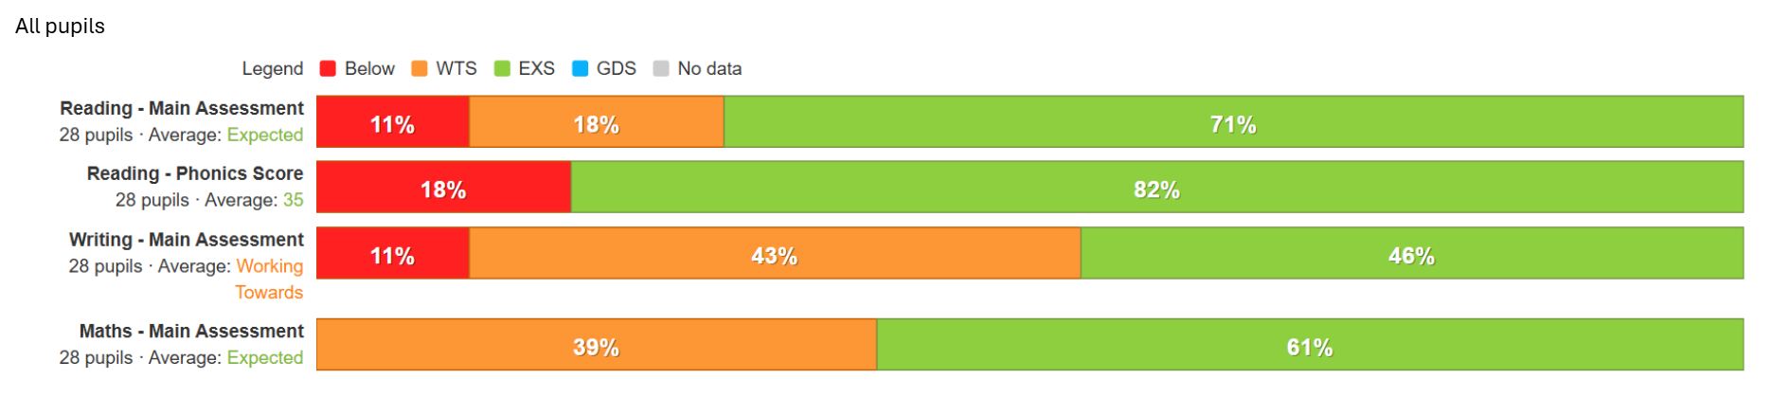
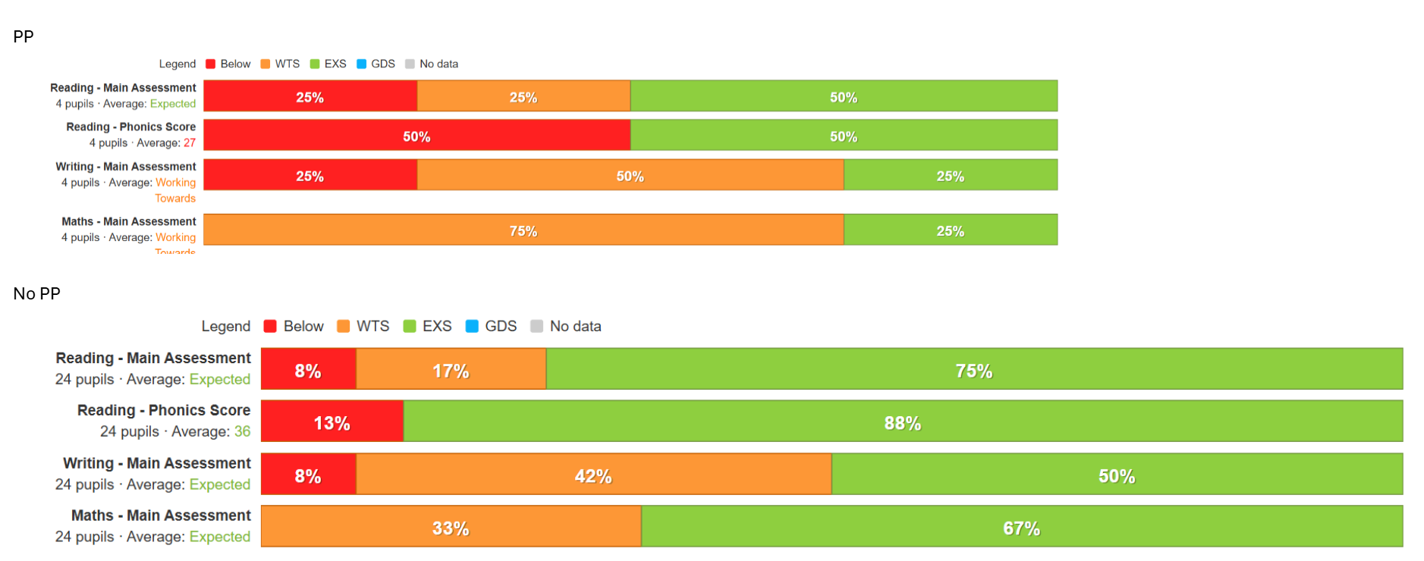
We are continuing to develop our SEND offer and have trained staff to deliver a range of intervention programmes to support pupils SEMH needs. Employing a higher ratio of support staff has also allowed for an increase in targeted support in the classroom along with 1-1 SAL support using the speech and language link programme this allows for more success in the classroom.
Increased opportunities for pupils eligible for pupil premium:
From September 2024 the school expanded its offer of extra-curricular clubs. Increasing engagement of disadvantaged pupils will continue to be targeted for the academic year 2025 /26
Grace Cook is resolved to maintain a high-quality curriculum which is enhanced by rich experiences such as trips, visitors and continues to fund these from the school budget. All pupils were able to attend school visits and access enrichment activities.

Externally provided programmes
Please include the names of any non-DfE programmes that you used your pupil premium (or recovery premium) to fund in the previous academic year.

Programme | Provider
Read Write Inc. | Phonics - Ruth Miskin Literacy
Dyslexia Gold intervention and screener | Dyslexia Gold - Reading Intervention
Speech and Language Link | Speech and Language Link
Hamish and Milo | Social and emotional learning - SEL & SEMH Programmes & Resources | Hamish & Milo
NTS assessments | Assessments to Support All Learners | Hachette Learning
Insight Tracking | Insight | Online Pupil Tracking for Primary Schools
Zones of Regulation CPD | Self-Regulation Curriculum | The Zones of Regulation

