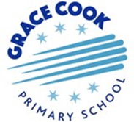

Early Years Foundation Stage Rationale
“The important thing is not to stop questioning. Curiosity has its own reason for existence.”
Albert Einstein
In the Early Years at Grace Cook, children learn within a safe and secure learning environment that equips them for the educational journey ahead. We ensure children are given a range of highly-engaging and motivating play-based learning experiences which enable them to become confident and independent learners.
The above quote encompasses everything that we aim to provide for children as they begin their journey with us, at the age of three years old. We endeavour to offer a curriculum that is based on real life experiences, involves the child and most importantly is planned through careful assessment of their needs and interests.
The Early Years Foundation Stage Framework provides us with the scaffold for our Early Years curriculum and learning is planned through the Curiosity Approach. By the end of the Reception year, our intent is to ensure that all children make at least good progress from their starting points and are equipped with the skills and knowledge to have a smooth transition into Year 1.
Intent – why do we teach what we teach?

At Grace Cook we use the Development Maters: Non-statutory curriculum guidance for the early years foundation stage (July2021), to support us with the delivery of our curriculum building on the strengths and meeting the needs of all children from the age of two years old.

Our curriculum is play-based and encompasses the seven areas of learning and development. Our Early Years team is committed to providing an environment that is rich with possibilities, develops children’s independence and puts children right at the centre of their own learning.
The intent of our EYFS curriculum is to;
C create an environment that ignites curiosity
U use authentic resources to create a unique curriculum
R recognise children’s prior learning
I allow children to be independent and engage in quality interactions
O offer opportunities to talk and listen to develop life skills – Oracy
S believe that every child can succeed
I foster curiosity and investigation which in turn develops children’s involvement and engagement in their learning.
T support children to be thinkers of the future
Y building resilient learners yes we can do it!

“We keep moving forward, opening new doors, and doing new things, because we’re curious and curiosity keeps leading us down new paths.”
Walt Disney

Implementation – how do we teach what we teach?

Our practice is underpinned by the Curiosity Approach. Through The Curiosity Approach, we feel confident that we are setting our children up for life, with the skills and knowledge necessary to survive our fast and ever-changing world. We believe that play with all its language, physicality and social interaction is what gives children the right and appropriate grounding for their educational journey. Play is our fundamental principle but alongside this, we also incorporate direct teaching times across each day to introduce and consolidate skills in communication and language, literacy mathematics and personal, social and emotional development. In Reception our weekly timetable consists of daily sessions of Literacy, Maths and Phonics with children engaging in adult focused, adult initiated and child led activities. During the afternoon children have the opportunity to explore the outdoor environment in ‘Welly Wednesday’ and ‘Discover and Do’. The outdoor learning environment is stimulating and responsive to children’s ideas and children are active, motivated and purposeful.

Through the curiosity approach, we plan exciting and enriched learning activities, creating a sense of awe and wonder through our creativity which is based on real life experiences and authentic resources.

Our approach fosters children’s preferred learning styles and allows children to demonstrate all the characteristics of effective learning. We provide children with the opportunity to be explorers, to be actively involved in their learning, as well as being creative and critical thinkers through the planning of open ended tasks. We also value the importance of learning outdoors and enjoy using our designated outdoor areas and gardens within our everyday planning.

We ensure that all our learning environments provide:
- stimulating resources, relevant to all the children’s cultures and communities
- rich learning opportunities through play and teaching
- support for children to take risks and explore.

Reading
Reading is at the heart of our Early Years curriculum and we endeavour to encourage a love of books right from the first moment a child joins us in our Grace Cook Nursery. Across the EYFS we have a literature spine which aims to expose children to a range of books that not only develop a love of reading, but have been chosen specifically to develop their oracy, vocabulary, comprehension and understanding of the world around them.

In the Nursery and Reception a text is used as the starting point each week upon which we base children’s learning. The weekly text becomes embedded across our learning environments through a range of cross curricular activities. It is through this approach that children begin to internalise new vocabulary, language patterns and begin to retell stories.

There is cohesion and consistency with our approach to align with the whole school Literacy
Curriculum that is followed in KS1.
• The inclusion of high-quality texts which are age and stage appropriate
• Modelled reading and re-telling opportunities across each session
• A focus on Tier 1, 2 and 3 Vocabulary
• Dedicated phonics sessions,
• Cooperative learning behaviours which develop oracy and interdependence

Writing

Writing skills are clearly outlined in an age appropriate and progressive way so that the children’s writing is extended as they progress throughout the EYFS and into Year 1.

We ensure that children have the opportunity to make marks and practise their writing skills across all areas of learning both indoors and outside. We recognise that mark making and handwriting require two key physical skills: (1) dexterity and (2) fine motor function. This mechanical part needs to be coupled with the ability to assign representations to marks and later on to use symbols like letters to write words.

Children are given regular opportunities to experiment with making marks from the time they join us in our nursery using a range of resources as well as their body to create marks. A child needs to develop a range of skills to be able to use mark-making tools effectively; physical skills like dexterity and coordination, cognitive skills like symbolism but more importantly than all motivation to make marks and writing for a purpose. Staff ignite this passion in children by displaying fascination in the children’s mark-making journey and through providing a range of opportunities to celebrate the achievement and development of their skills. They act as role models engaging in writing with the children demonstrating that writing has a purpose and most importantly they ensure children feel secure enough to ‘have a go’, learn new things and be adventurous.

Phonics
At Grace Cook children learn to read using the Read Write Inc phonics programme (RWI). RWI is a systematic approach to learning letters and sounds that enables children to read and write successfully. A child who reads for pleasure is a reader for life. Grace Cook’s aim is to establish each child as a lifetime reader based on developing a love of reading. We ensure our children are given a rich curriculum which encourages reading of books and other kinds of texts.
Through RWI children will;
- Learn 44 sounds and the corresponding letter.
- Use pictures as a prompt for recognising sounds
- Use Fred talk to encourage blending of sounds to read words. Fred can only read pure sounds, so the children help Fred by blending the sounds so that they can help him to read a whole word!
- Read books suited to their reading ability with confidence and fluency, using a story tellers voice
- Answer questions about stories showing good comprehension
- Have daily story time

In Reception every child has access to a daily phonics session with intervention ‘keep up’ one to one sessions provided for those who find this area of learning more difficult. We use the phonics session to also develop children’s expertise in handwriting. We teach pre cursive handwriting and children write at tables in books with lines.

Mathematics
At Grace Cook we understand the importance of early experiences of maths and through our approach we place a significant emphasis on developing a strong grounding in number – understanding that this is a necessary building block for children to excel in the subject. Developing “number sense” is a crucial part of early maths learning: it helps children to understand what numbers mean, gives them the ability to be flexible with numbers, and, ultimately, sets them on the path to becoming great mathematicians.
Children at the expected level of development for number at the end of the reception year will
- Have a deep understanding of number to 10, including the composition of each number;
- Subitise (recognise quantities without counting) up to 5;
- Automatically recall (without reference to rhymes, counting or other aids) number bonds up to 5 (including subtraction facts) and some number bonds to 10, including double facts.
- Verbally count beyond 20, recognising the pattern of the counting system;
- Compare quantities up to 10 in different contexts, recognising when one quantity is greater than, less than or the same as the other quantity;
- Explore and represent patterns within numbers up to 10, including evens and odds, double facts and how quantities can be distributed equally.

EYFS staff provide daily creative and engaging opportunities for children to ignite their curiosity and enthusiasm for the subject and build upon and apply their developing understanding of number and spatial reasoning. Through the Curiosity approach concrete manipulatives are a key focus within each session, as is the use of pictorial representations including fives and tens frames. Children are actively encouraged to use mathematical terminology within their understanding, with a focus on developing positive attitudes and interest in the subject.

The Wider Curriculum

Our wider curriculum is taught through the learning areas; ‘Understanding the World’ and ‘Expressive Arts and Design.’ EYFS staff have a good understanding of how ELG’s feed into the National Curriculum through our half termly curriculum coverage grids and our long term plans.

Exciting and meaningful activities are planned to build on children’s natural curiosity. These will stimulate their senses as well as encourage them to ask questions, explore and wonder at their environment. They will undertake investigations that engage their interests, and develop awareness of the beliefs and views of others.

Impact – how do we know what pupils have learnt and how well they have learnt it?

Our EYFS curriculum provides a sustained high quality, well planned and progressive curriculum for the unique child. We ensure our staff have a good knowledge of child development to ensure progress and attainment are tracked clearly starting with our youngest learners.

The positive relationships developed between staff and children ensure that children are self-confident and have a high level of self-esteem and resilience. In addition to this the children’s level of involvement ensures they are intensely engaged in activities which encourage deep level learning and development. This can be seen through the active learning environments which have a ‘buzz’ of learning as they ‘get busy’.

Our curriculum must meet the needs of all our children, including our disadvantaged pupils and
those with SEND, so we spend time looking at and evaluating how children are learning. This is achieved through talking to children, looking at their work, observing their learning experiences and analysing data and progress by year group, class, groups and individuals.

Every member of staff uses ongoing observational assessment to identify children’s starting points and plan experiences which ensure progress. This information is tracked through Arc Pathway, which enables us
to recognise the importance of children being able to:
- follow their curiosity,
- master new skills
- develop and demonstrate independence
- push themselves to become increasingly competent learners.

Through assessing every child across each of the ‘Arc Strands’ we achieve a holistic view of their learning and development. During each assessment window, teachers update the progress children have made in their individual pathways which allows us to assess the impact of teaching and set meaningful and appropriate next steps.

Evidence of children’s learning including observations, work samples, photographs and contributions from parents are kept in paper ‘learning journals’ which children use to reflect on their progress through pupil voice.

Our curriculum and its delivery ensures that children make good progress. During their time at Grace Cook in the EYFS, children make rapid progress so that we meet the national expectation for GLD at the end of the year. Pupils also make good progress toward their age-related expectations before transitioning into Year One. We believe our high standards are due to the enriched curiosity play-based exploration alongside the rigour of assessment and teaching the children have as they move through the early years – a rich diet of balanced learning experiences is undoubtedly the best way to develop happy, curious children.

Parental Involvement
We believe that all parents have an important role to play in the education of their child, recognising the role that parents have played, and their future role.
Parents are encouraged to join in with their child’s education from the very start of their school journey. In nursery home visits take place and all parents are invited to join in with ‘stay and play’ sessions and a range of other annual events/fundraisers.
The learning and development requirements of the Statutory Framework for the Early Years Foundation Stage (EYFS) state that:
At Grace Cook we value the importance of the three-way relationship between children, parents and staff, as it enables children to make good progress and to maximise their potential. In Reception parents are encouraged to support children’s learning through completing homework activities set on the online platform Dojo, hearing their child read and through completing termly questionnaires about their child’s progress and attainment. Formal parents meeting are offered in the autumn and spring term, where parents have the opportunity of speaking with the teachers to discuss their child’s progress and development, identify their next steps in learning and to view their child’s work.
Inclusion
Our whole school ethos, as well as that of the Early Years, embraces inclusion. We recognise and respect the abilities and strengths of our children at all levels of development and the wealth of knowledge and experience that they bring from their differing backgrounds and cultures.
We give our children every opportunity to achieve their best. We do this by taking account of our children’s range of life experiences when planning for their learning and we set realistic and challenging expectations that meet the needs of individual children, so that children are able to reach their full potential. We achieve this by planning to meet the needs of boys and girls, children with special educational needs, children who are more able, children from all social and cultural backgrounds, and children of different ethnic groups. We aim to build upon and extend children’s knowledge, experience and interests, and develop their self-esteem and confidence using a wide range of teaching strategies based on children’s learning needs
We provide: a wide range of opportunities to motivate and support children and to help them to learn effectively; a safe and supportive learning environment in which the contribution of all children is valued; resources which reflect diversity and are free from discrimination and stereotyping; challenging activities for all children and for those whose ability and understanding are exceeding. We will monitor children’s progress and take action to provide support as necessary. Where a specific need is identified we will liaise with the Special Educational Needs co-ordinator and seek advice from outside agencies, such as the speech and language service.
Early Years Pupil Premium – we endeavour to identify our least advantaged pupils and inform parents or carers of their opportunity to apply for their child’s entitlement to extra funding in school. All extra funding, we receive will be used to support areas in which we identify that the child will best benefit. We will track children’s progress to ensure that they are making good progress and to ensure that support is adjusted to target specific areas as the child develops.

Transition
We have a comprehensive transition programme in place across the EYFS. In nursery our staff visits every child in their home setting before they begin. Children and their parents are then invited in for two stay and play sessions and a parent’s meeting, providing information about routines and the curriculum.
In Reception during the summer term all feeder settings are invited to a transition meeting in school to discuss ways in which they can support children with the move from pre-school to school. The reception teachers carries out visits to each setting to meet the children and discuss their development, attainment and progress with staff. This is followed with a whole week of activities planned for the new children and their families in school. This includes an outdoor session with parents staying, morning and afternoon play sessions, a half a day including experiencing lunch and an opportunity for both parent and child to meet their teacher on a one to one basis.
We want the children at our school to experience a smooth educational and emotional transition from one phase to the next. Successful transition takes careful thought and thorough planning well in advance. With input from the Reception and YR 1 team a transition timetable is produced. This will contain the different activities and time slots that will be dedicated to the transition of the children from Reception to Year 1. This will include at least one ‘moving up day’ where the time is dedicated to children going up to their new classes. SEND children have regular visits to Y1 classes at different times, e.g. break, storytime, music, with a familiar adult accompanying them.
Assessment handover meetings take place in the summer term during when the Y1 teacher meets with the Reception teacher to discuss EYFS data. Children are discussed in detail with individual needs covered and targets agreed for children to continue working on in the autumn term. Reception and Year 1 teachers share professional knowledge and the Reception teacher takes time to explain the EYFS assessments that are in place. We aim to ensure that the Year 1 teacher broadens their understanding of the EYFS. Senior leaders and the Year 1 team discuss the autumn term planning strategies and where applicable tailor it to the needs/interests of the cohort. Year 1 plans ensure that the children gradually become more independent through high expectations of individual and group work. Activities are interactive, with a mixture of adult led and child initiated. The plans follow the National Curriculum, with challenges for the children who are ready. Year 1 teachers organise their classrooms to provide quality teacher directed activities in addition to planning for quality continuous provision. Resources are used to maximise learning opportunities and used to promote creativity, awe and wonder and to maximise the use of the outdoor learning spaces to reflect reception provision.

Grace Cook Nursery
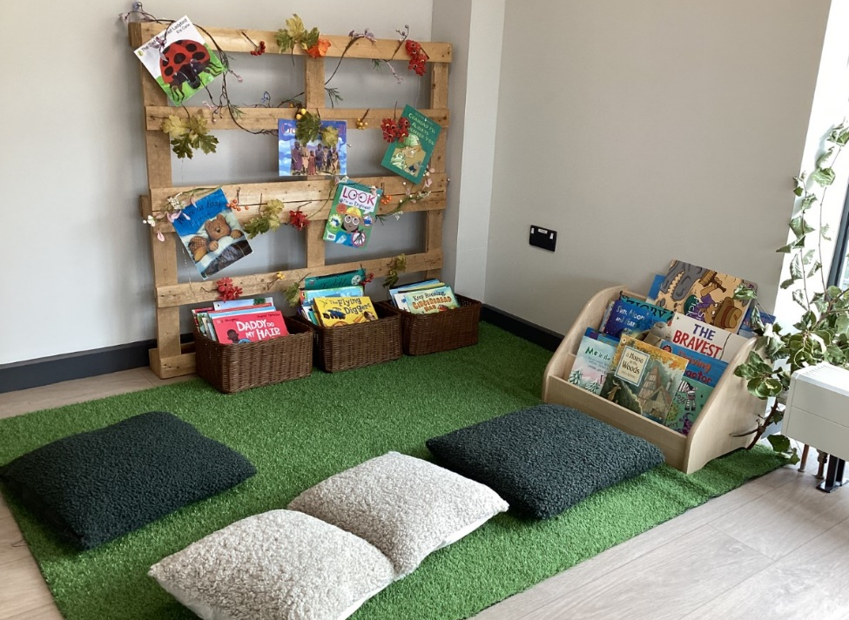
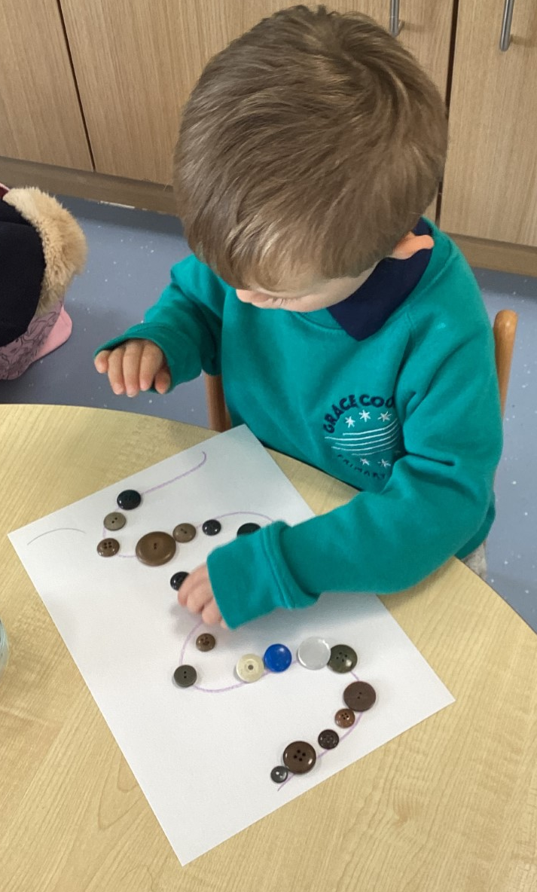

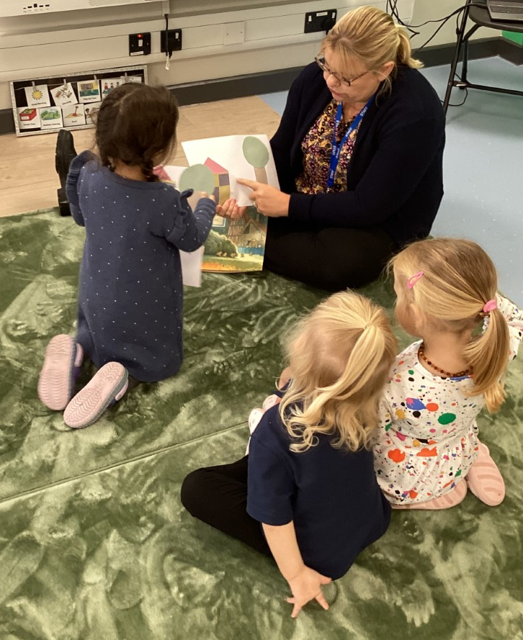

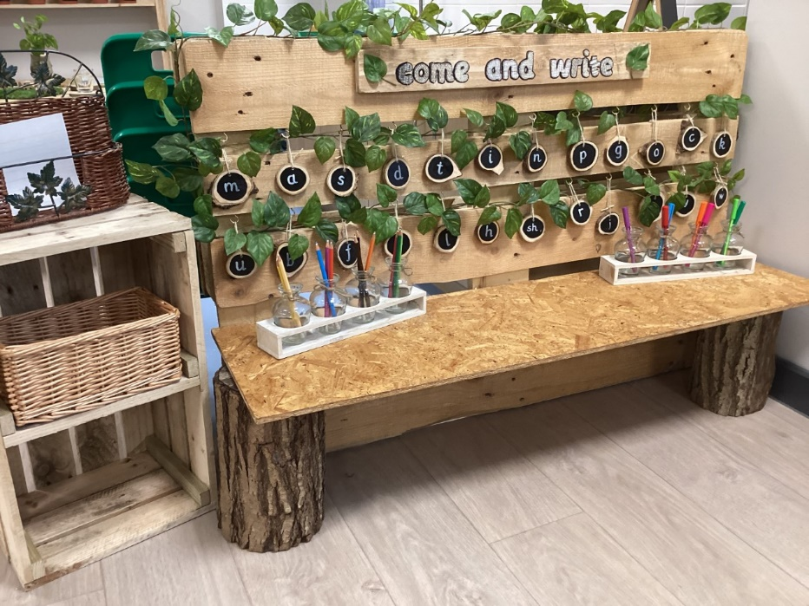
Reception


