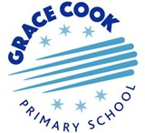

CUSP – Curriculum model
Launch of CUSP Curriculum - September 2022
We have decided to implement the Unity Schools Partnership CUSP curriculum model written by Alex Bedford of Unity Schools Partnership.

This comprehensive curriculum model is based heavily on research around the working memory, cognitive overload, and retrieval. The new curriculum resources we have purchased will support teachers to plan and teach History, Geography, Science, Art and Design, Design and technology and English Reading and Writing as the school grows.

Important Vocabulary and Oracy foundations
‘There is an emphasis on oracy and vocabulary acquisition, retention and use; to break down learning barriers and accelerate progress. ‘
- https://www.unitysp.co.uk/cusp/

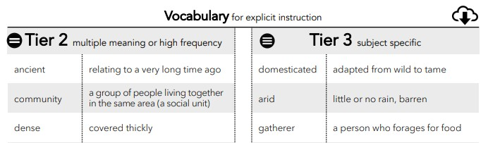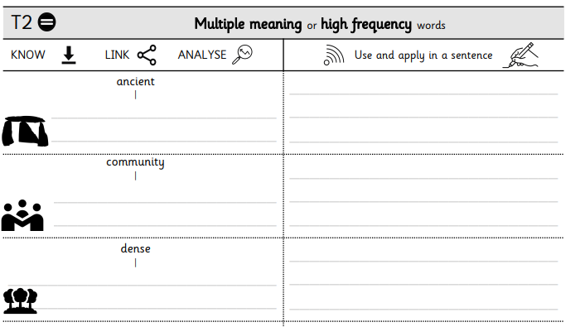Developing our children’s oracy skills is an important part of our key curriculum driver for our children to become – ‘Confident Communicators’ and in line with our Voice 21 initiative. Careful planning making use of Rosenshine’s principles of direct instruction aims to ensure the effective, specific teaching of essential vocabulary within the CUSP modules. Plans detail the etymology and morphology of words and suggest scaffolds to teach vocabulary.

Structured, coherent and ambitious learning
The CUSP curriculum has been carefully developed and structured. Units of learning - ‘modules’, are logically placed within and during specific year groups and terms to build upon what children have already learnt and understood within and across subjects. Each learning unit identifies expected learning from previous year groups and then the big ideas and key enquiry questions for each lesson which the children will acquire knowledge and understanding to be able to answer as they progress through the modules.
School adaptations
During the transitional phase of implementation, thoughtful decisions have been made about which key content each year group will cover and adjustments have been made in the History overview for example, to ensure key periods in British history are taught in chronological order.
Spaced Retrieval Practice Approach
The CUSP model is built upon the research of interleaving and spaced retrieval, therefore the module approach with children studying Geography over the week, every 3 weeks for example, ensures children have time to ‘forget’ and then recall previous learning; thus, affirming this learning imprint in a child’s memory. Purposeful decisions are made to make links between subjects, adding depth to children’s knowledge and making effective use of this valuable learning in subjects including English writing.
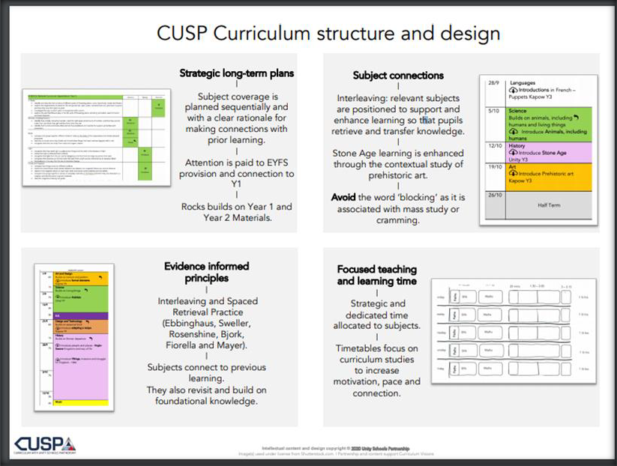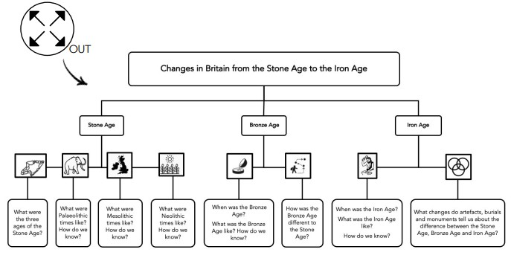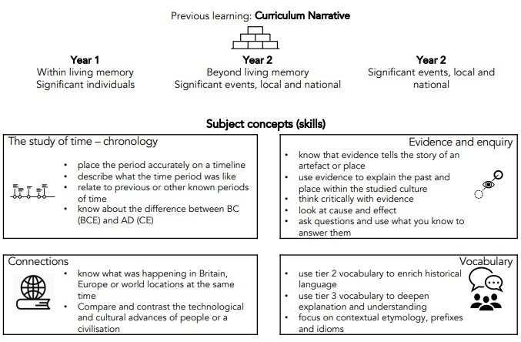

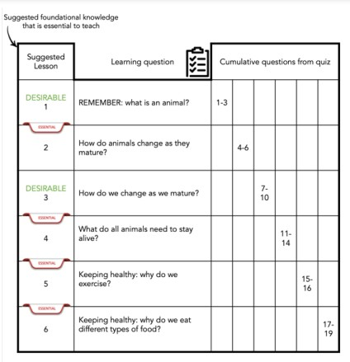Careful Sequencing of lesson content
Careful lesson sequencing with key enquiry questions
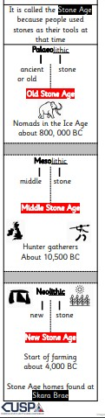
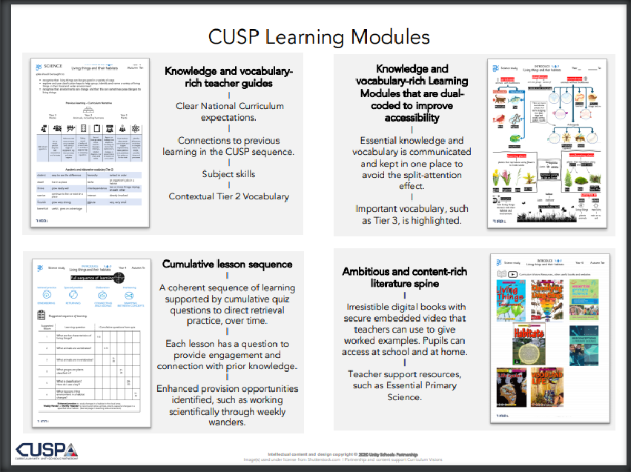CUSP curriculum has carefully sequenced lessons with ‘Essential’ and ‘Desirable’ knowledge suggested for teachers. This gives teachers responding to our Covid -19 Recovery priority, the ability to prioritise essential knowledge or revisit key learning so as to make the best use of curriculum time. Highly effective ‘Knowledge Strips’ - essential knowledge for each lesson which is organised for teachers and children using key words and pictures (Dual coding) supports accessibility for children with Cognition and Learning SEND needs.
Knowledge Strips

